Name : S.MANSOOR

REG No: 192111658

EXP NO: 1 DATE:04/05/2023

CREATE A SIMPLE CLOUD SOFTWARE APPLICATION AND PROVIDE IT AS A SERVICE USING ANY CLOUD SERVICE PROVIDER TO DEMONSTRATE SOFTWARE AS A SERVICE (SAAS).

AIM:

# To create a simple cloud software application and provide it as a service using it as a service using any cloud service provider to demonstrate Software as a Service (SAAS).

PROCEDURE:

# STEP1: GOTO ZOHO.COM

STEP 2: LOGIN TO THE ZOHO.COM STEP 3: SELECT ONE APPLICATION STEP 4: ENTER APPLICATION NAME STEP 5: CREATE A NEW APPLICATION STEP 6: SELECT ONE FORM

# STEP 7: THE SOFTWARE HASE BEEN CREATED.

IMPLEMENTATION:

STEP1: GOTO ZOHO.COM

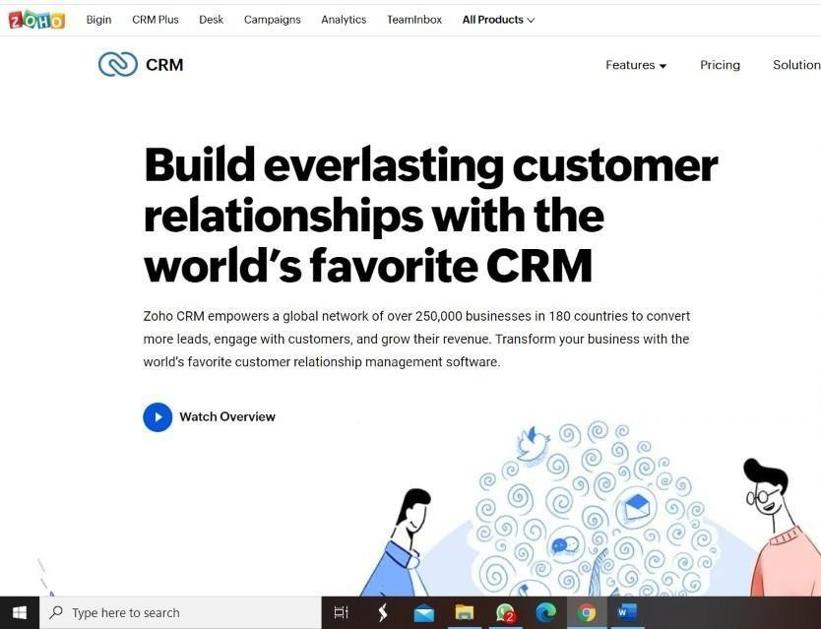

STEP 2: LOGIN TO THE ZOHO.COM



STEP 3: SELECT ONE APPLICATION

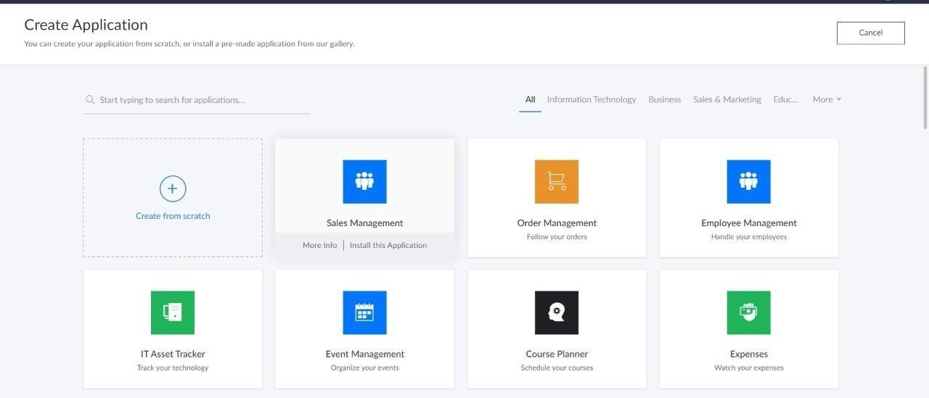

STEP 4: ENTER APPLICATION NAME

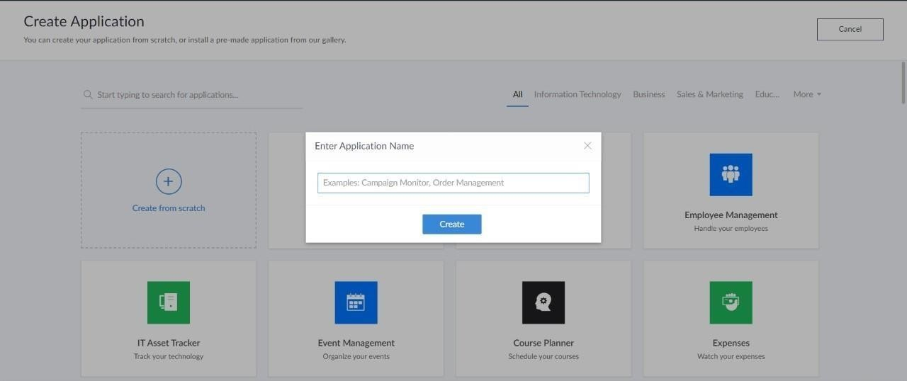

STEP 5: CREATED NEW APPLICATION

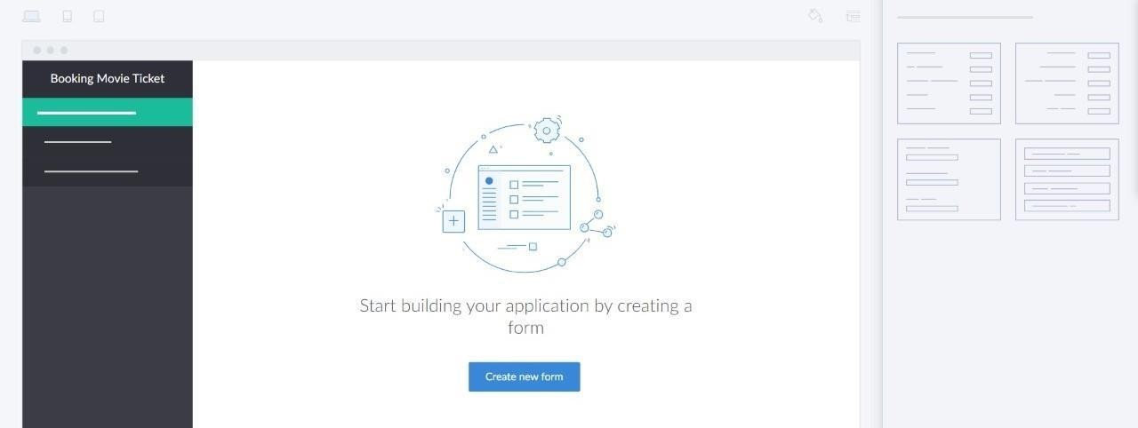

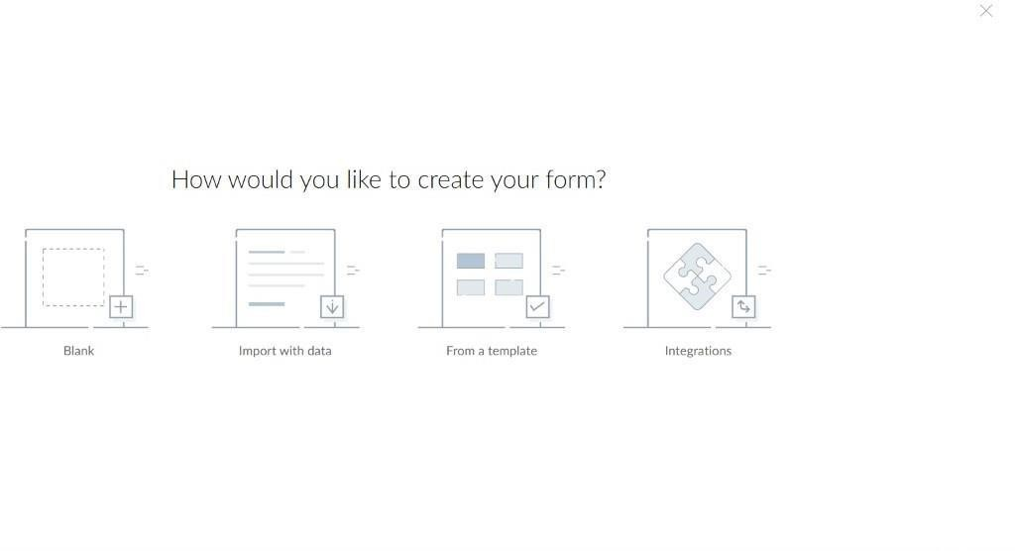STEP 6: SELECT ONE FORM

STEP 7: THE SOFTWARE HASE BEEN CREATED.

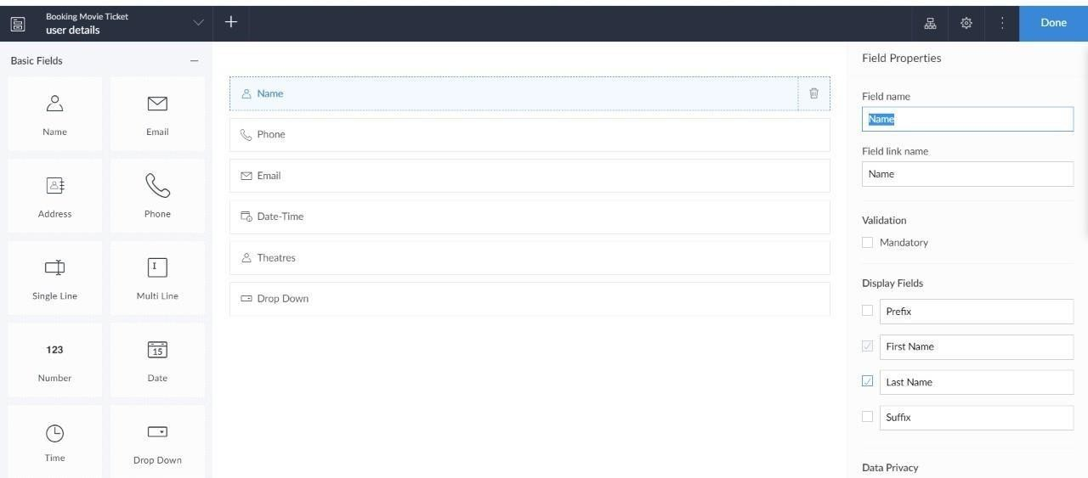

OUTPUT:

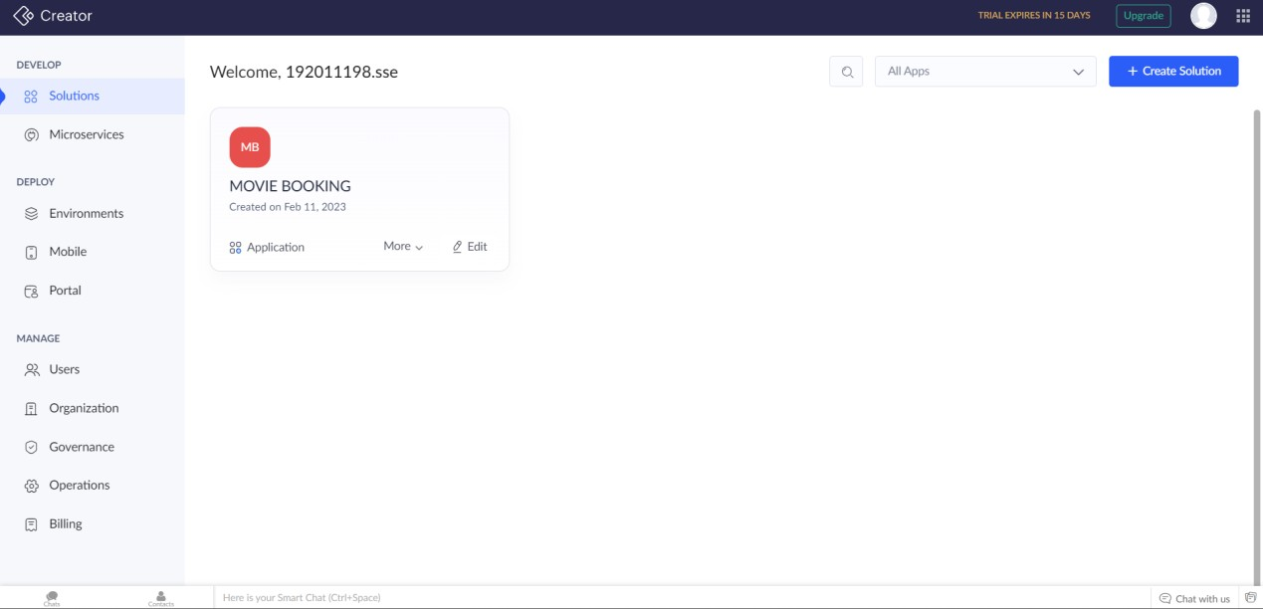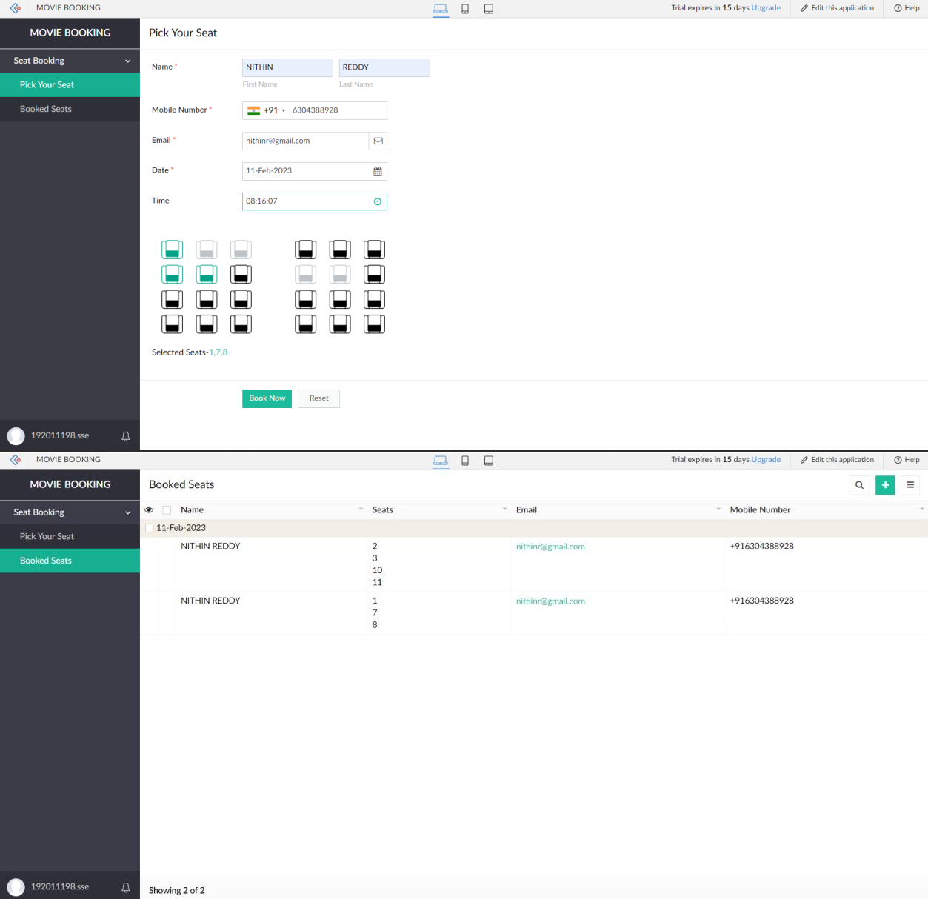

RESULT:

**Hence The Creation of a CREATE A SIMPLE CLOUD SOFTWARE APPLICATION AND PROVIDE IT AS A SERVICE USING ANY CLOUD SERVICE PROVIDER TO DEMONSTRATE SOFTWARE AS**

**A SERVICE is performed sucessfully**